**Protocol for Excitatory Synapse Data Extractor**

Given a series, the program will create a CSV file containing data on mitochondria, vesicles, glia, and MSBs for each excitatory synapse.

1. If Python is not already installed on your computer, download the latest version for Windows at <https://www.python.org/downloads/>
   1. Run the EXE file that is downloaded. The installer screen should then pop up:

Please ensure that “Add Python [version] to PATH” is checked – it is not checked by default. After confirming this, click on “Install Now.”

* 1. Once the installation has finished, a message saying “Setup was successful” will be displayed. At this point, you can close the window. Python is now successfully installed on your computer.

1. Export all objects and their count, flat area, and volume data into a CSV file
   1. Open RECONSTRUCT, open the options menu (Ctrl+O) and go to the “Lists” tab.
   2. Under “Object List,” make sure “Limit To:” is set to *
   3. Under “Object List,” check only the “Count” “Flat Area” and “Volume” options.

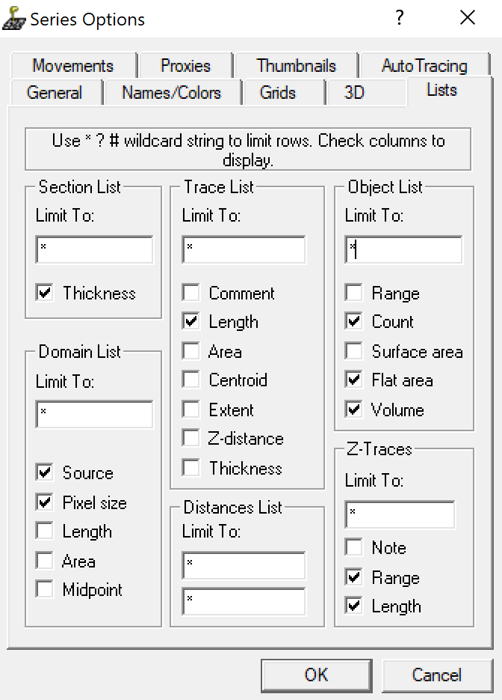

* 1. Once this is completed, hit OK.
  2. Open the “Object” menu at the top of the RECONSTRUCT window and select “List Objects…”
  3. On the object list window that pops up, open the “List” menu at the top and select “Save…”
  4. Save the file in a desired place on your computer. When saving the file, make sure to add .csv to the name (ex. myfile.csv)

1. Download the Python code from <https://github.com/julian-falco/ExtractESynapseData> by clicking on the green button that says “Code” and clicking “Download ZIP.” The program will be downloaded as a zipped folder.

1. Open the zipped folder and run the Python file (ExtractESynapseData.py)
   1. You can do this by double-clicking the file.
   2. Feel free to extract the contents of the zipped folder and/or run the program in IDLE.
2. Once the program starts running it will ask for the following:
   1. The file name or path for the CSV file created in step 2
      1. If the file is not in the exact same folder as the program, find the csv file in your file explorer. Copy the file path (circled in red below):

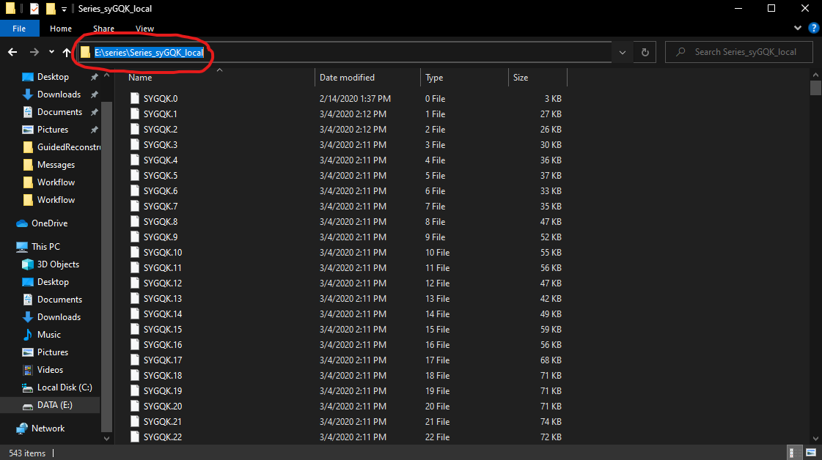

* + 1. Paste this exact path into the program, then add a backslash character (\) and type out the full name of the CSV file (ex. C:Documents\files\myfile.csv)
    2. The name of the dendrite you wish to collect data for (ex. d013)

1. At this point, the program should start running on its own. If the window displays an error, there may have been something that was entered in wrong – re-run the program and double-check that everything is entered correctly. The program will ask you what you want to name the new CSV file with the organized data. Once again, ensure that that the file name ends with “.csv”. After the program finishes, you will receive a message asking if you want to extract data from another dendrite.